

**We are happy to inform you that the Golden Crown Haifa joined the Golden Crown hotel Chain.**

**The hotel is situated in the German colony in Haifa**

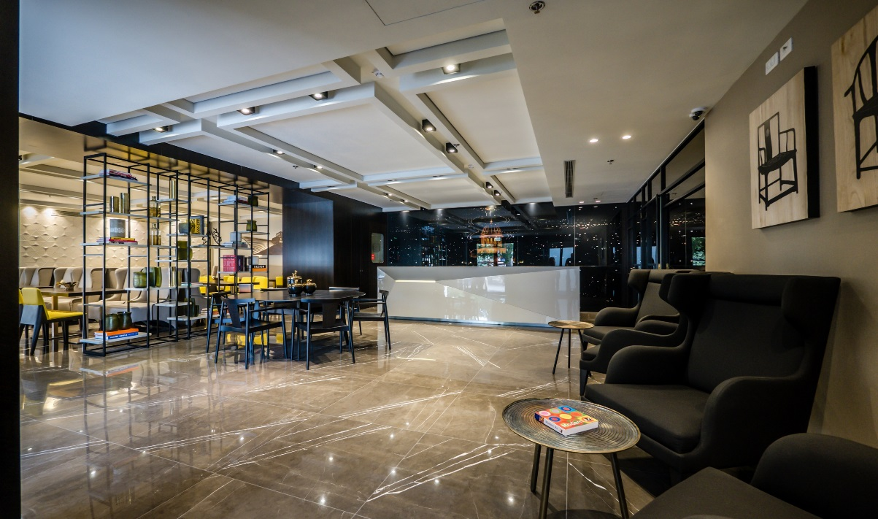

*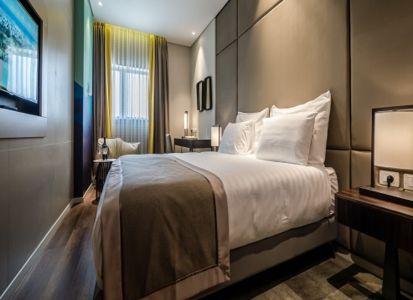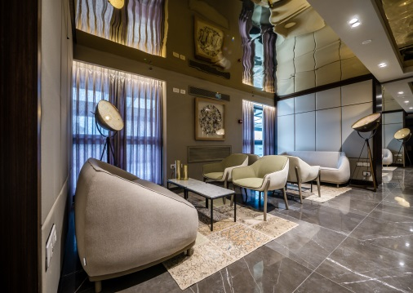***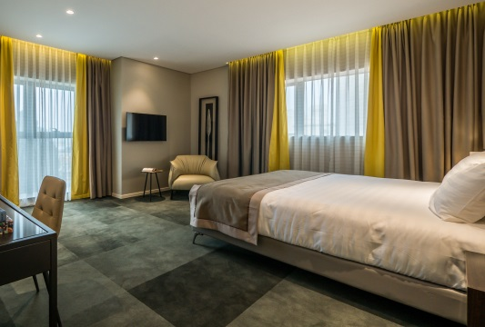**

**­­**

**Location**

Golden Crown Haifa Hotel is the third hotel in the Golden Crown hotels chain.

The hotel is situated in the German colony in Haifa (the entrance is from Jaffa Street), which is full of tourist attractions, restaurants and cafés.

From one side of the hotel you can enjoy the view of Haifa's Port and from the other side to the Baha'i gardens.

In addition, the hotel is near Haifa downtown, where you can find many commercial centers.

The hotel is attractive for business travelers due to its proximity to business centers.

Also, the Haifa center train station is a 10-minute walk from the hotel (700 meters).

**Rooms**

90 rooms are decorated in a modern and advanced way, while placing emphasis on our guests comfort.

Our guests will enjoy a quiet, relaxing stay and quality sleep.

Every room has individual air-conditioning control, personal safe, mini-bar, coffee machine, smart TV, telephone and free wired & wireless Internet access for the hotel guests.

**The hotel's restaurant**

The hotel's restaurant serves an Israeli-Mediterranean breakfast combined with a rich lobby menu from the Italian-dairy cuisine and fish delicacy.

**"Marquis"- business lounge**

The modern business lounge spread over an area of 165 square meters and can be used by the business travelers for meetings and ongoing work,

**The lounge terrace and gardens bar**

Next to the elegant business lounge, our guests will enjoy a spacious terrace that spread over an area of 220 square meters.

The terrace is the perfect place for outdoor events in the summer and indoor events in the winter (up to 200 persons).

**Area attractions**

The German colony, the Baha'i gardens, Haifa Museum of art, National Maritime Museum, National Science Museum, sculpture garden, Stella Maris monastery, Haifa cable car, Haifa educational Zoo.

.